Data Communication and Network
LAB

FAROOQ AHMAD Experiment #11
17L4407 Lab Report # 10
BEE-5A

INTRODUCTION TO GRAPHICAL NETWORK SIMULATOR 3 (GNS3)

INTRODUCTION
In this lab session, we were introduced to graphical network simulator 3 (gns3). Graphical Network Simulator 3 or GNS3 is a network software emulator that is used to build complex networks. It allows the combination of virtual and real devices, used to simulate complex networks. It uses Dynamips emulation software to simulate Cisco IOS. GNS3 provides a graphical user interface to design and configure virtual networks, it runs on traditional PC hardware and may be used on multiple operating systems, including Windows, Linux, and Mac OS X. It allows simulation using Cisco Internetwork Operating Systems. It allows you to run a Cisco IOS in a virtual environment on computer. It is possible to simulate a large number of router platforms and PIX firewalls using GNS3. However GNS3 will provide around 1,000 packets per second throughput in a virtual environment.

OBJECTIVE

The course learning objective of this lab session was to introduce us to the graphical network simulator 3 (gns3). Moreover the objective of this lab session was to make us learn how to use the graphical network simulator 3 (gns3) and build a simple network topology on graphical network simulator 3 (gns3).

DESIGN PROCEDURE
TASK 1:
Build the following class C network shown in figure 11.1 with its default subnet mask and ping PC5 from PC1.

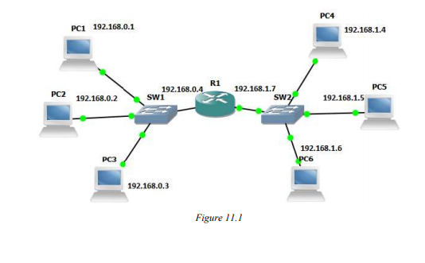
Testing->
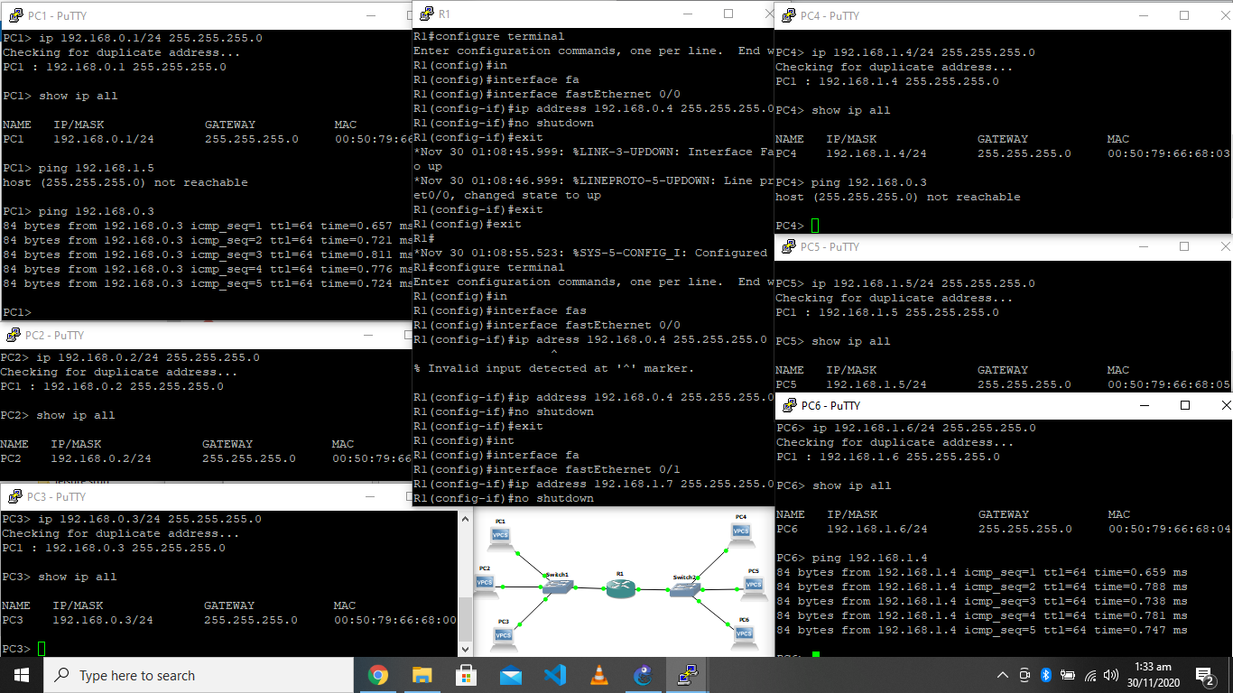
Actual->
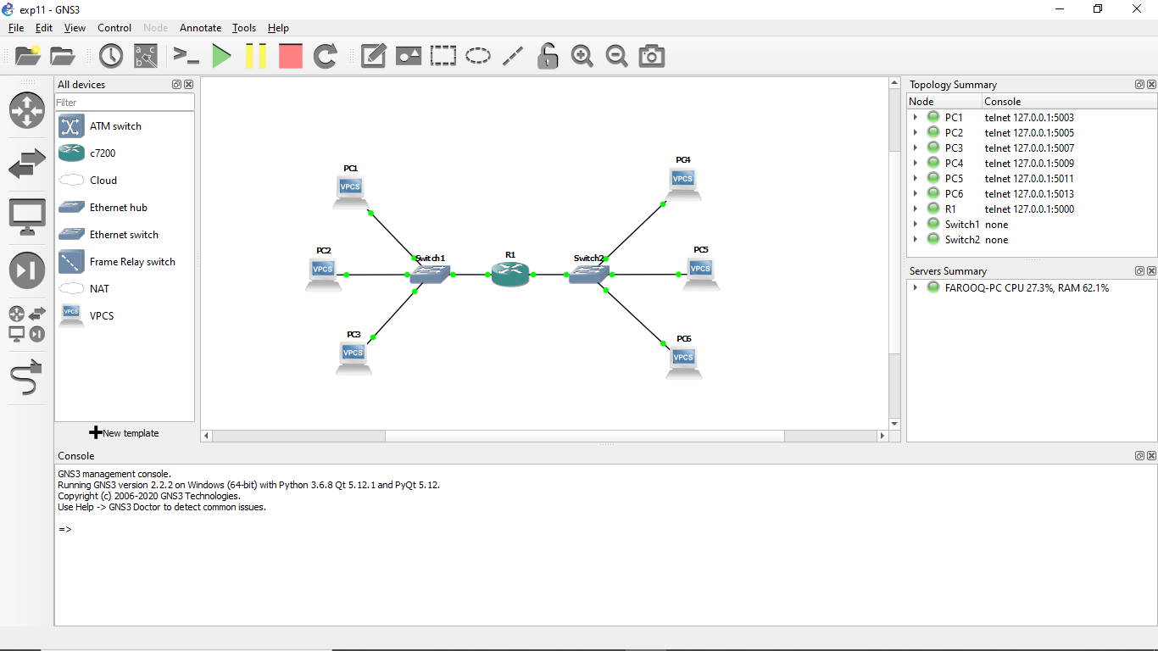
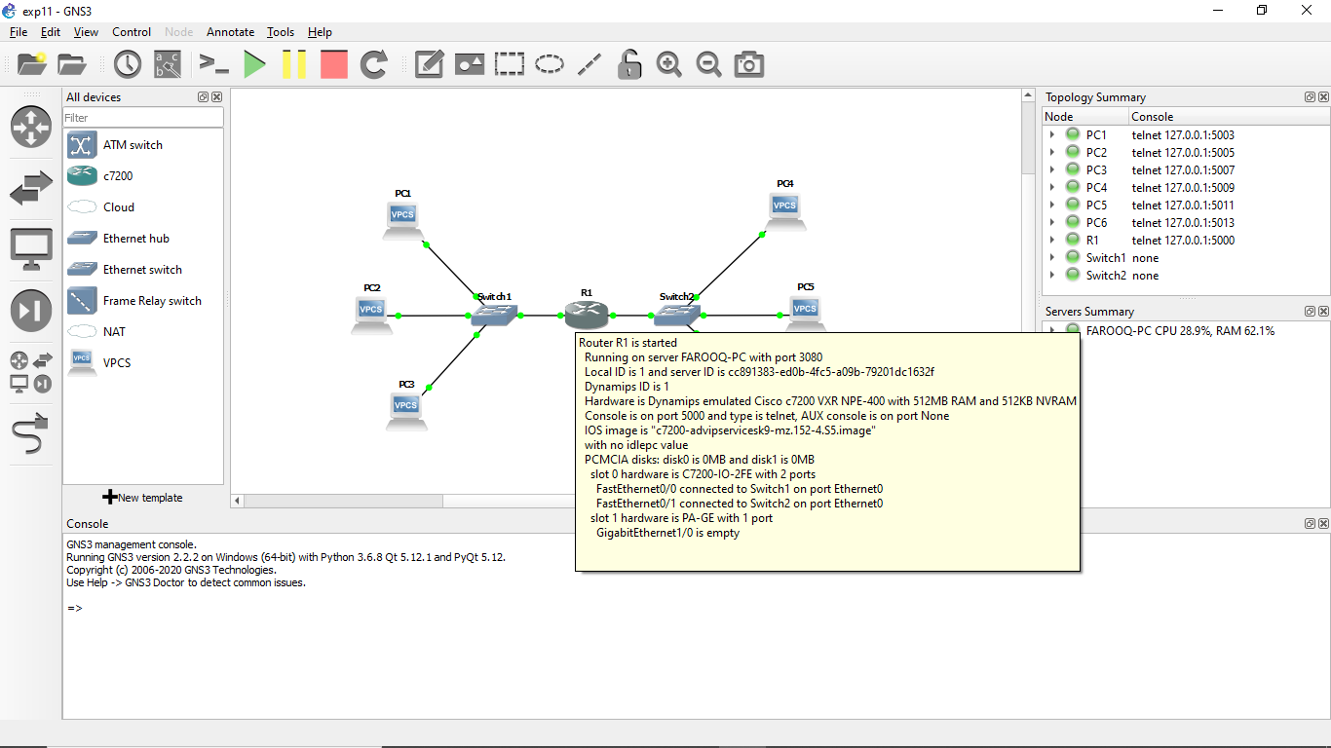

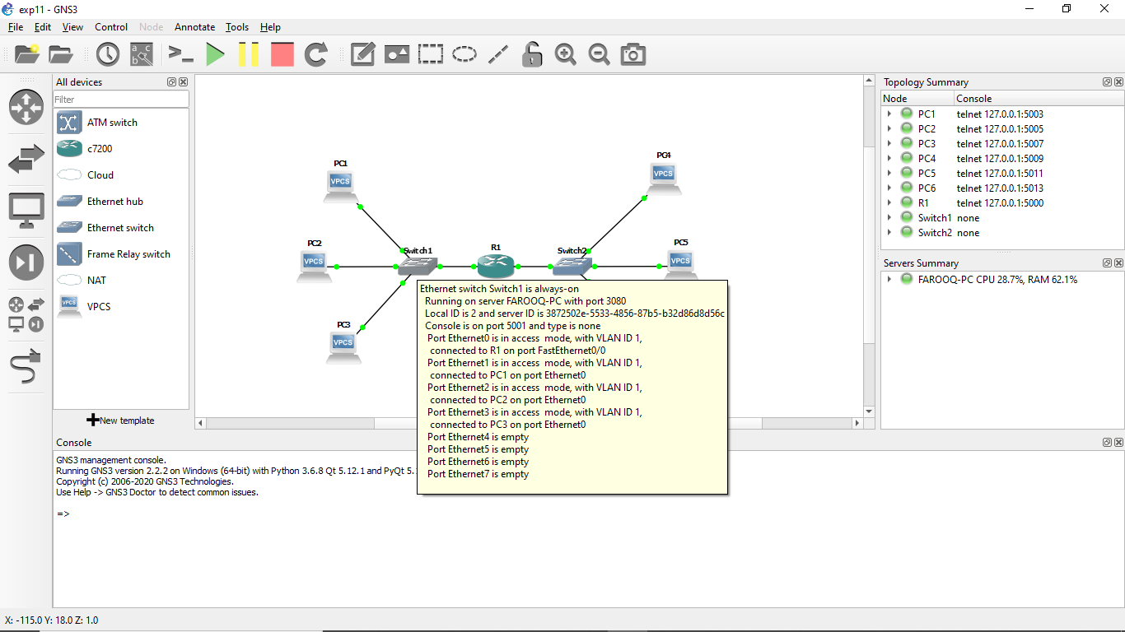
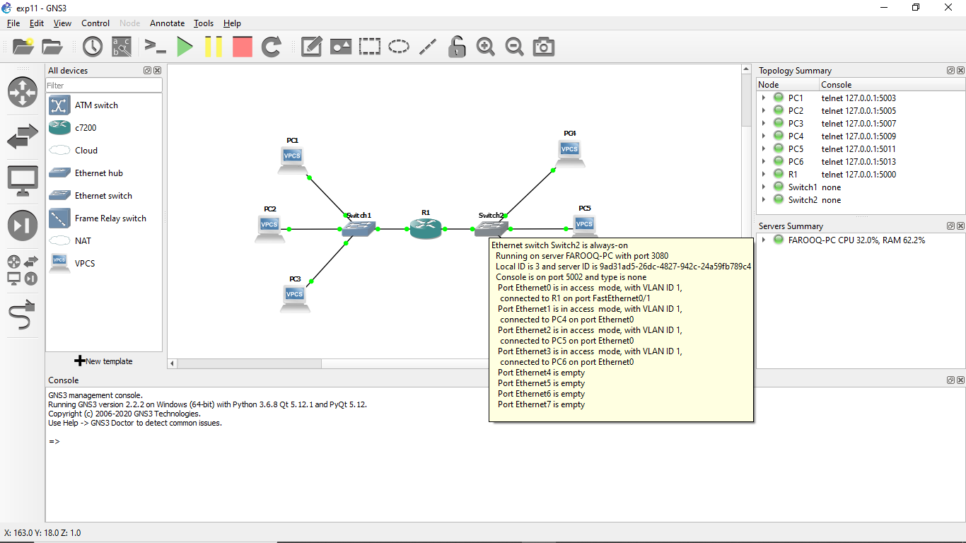
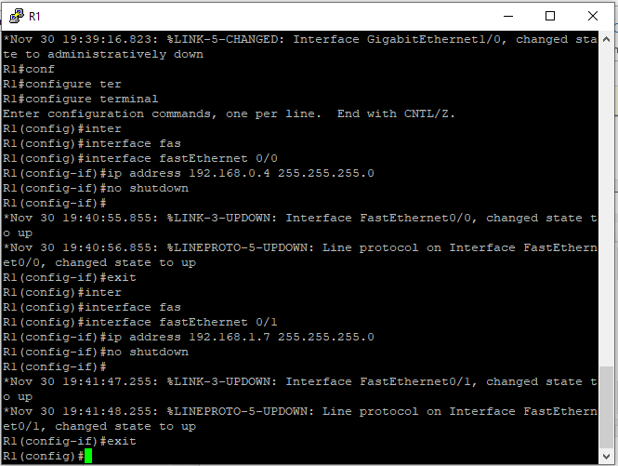

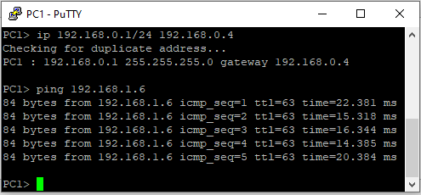
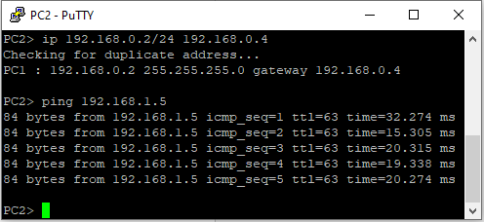
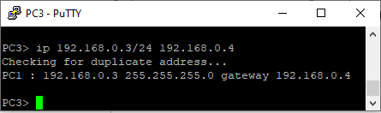
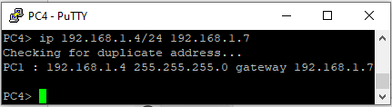
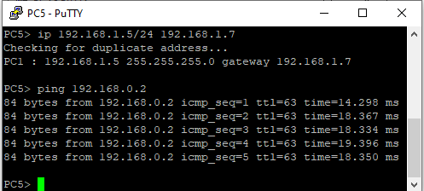
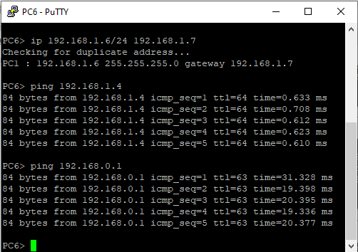
TASK 2:
Implement the following topology shown in the figure 11.2 with default subnet mask.
• Ping from HostA to HostB and Server
• Ping from HostB to HostA and Server
• Ping from server to HostA and HostB
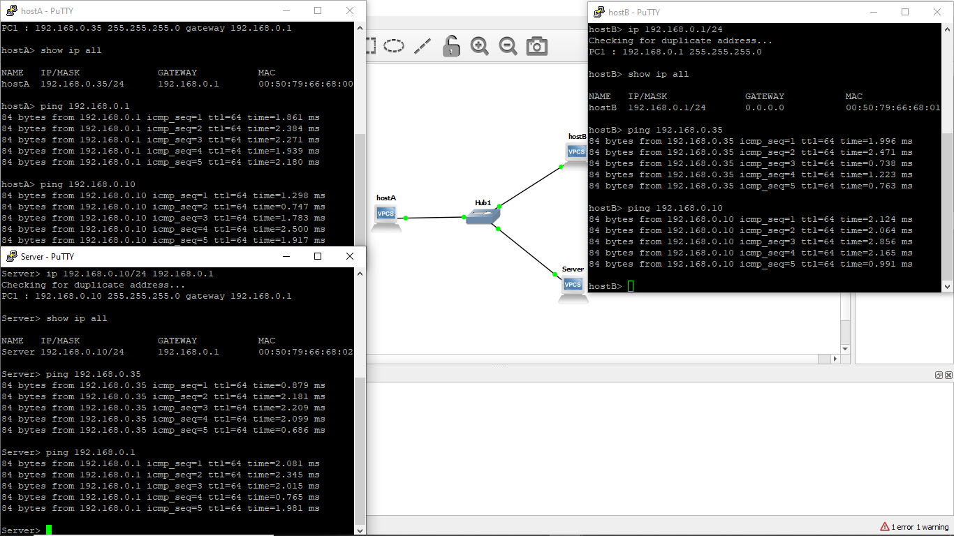
Now change the default subnet mask to 255.255.255.224 and perform the following:
Q. What is the effect of changing the subnet mask on the network?
The effect of changing the subnet mask, is that it effects how IP addresses are assigned.
It won’t let me assign the ip address claiming the error not same mask or invalid gateway.

ISSUES
There were as such none issues.

CONCLUSION
This lab session was conducted successfully. From this experiment we learnt how to use the Graphical Network Simulator GNS3 and how to build a network topology on a Graphical Network Simulator NS3. GNS3 is a graphical network simulator which lets you to create a virtual network. You don't need any hardware like routers, switches, or even endpoints (workstation computers). It is an open source software that simulate complex networks while being as close as possible to the way real networks perform. All of this without having dedicated network hardware such as routers and switches.

APPLICATIONS
GNS3 is a graphical network simulator which lets you to create a virtual network. You don't need any hardware like routers, switches, or even endpoints (workstation computers). This open source tool can be useful for setting up a local network in an office or other environments, and also for troubleshooting purposes. GNS3 provides a graphical user interface to design and configure virtual networks, it runs on traditional PC hardware and may be used on multiple operating systems, including Windows, Linux, and Mac OS X. It allows simulation using Cisco Internetwork Operating Systems. It allows you to run a Cisco IOS in a virtual environment on computer. It allows the combination of virtual and real devices, used to simulate complex networks. It uses Dynamips emulation software to simulate Cisco IOS. GNS3 is used by many large companies including Exxon, Walmart, AT&T and NASA, and is also popular for preparation of network professional certification exams.

